How to use the LENA DLP

What is a LENA DLP and what does it do?
LENA stands for Language Environment Analysis. DLP stands for Digital Language Processor. The LENA DLP is a special recording device that captures the everyday sounds around your infant. If you’d like to learn all kinds of cool things about LENA, check out their website: http://www.lenafoundation.org

How do I turn the LENA DLP on & off?
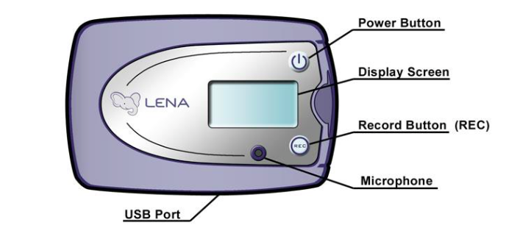
Press the Power Button to turn it on and press the Record Button (REC) to start recording.

To turn the LENA DLP on, press and hold the power button for about 3 seconds. The display screen will read “Paused”.

To start recording, press and hold the REC button for about 3 seconds. The display screen will read “Recording” and then everything is good to go!

To turn the LENA DLP off, press and hold the power button for about 3 seconds. This time, the display screen will briefly read “Power Off” and then go blank.

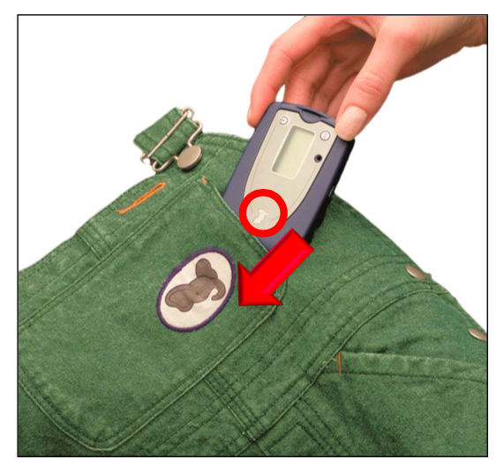
How do I record?
When your infant wakes up, “set it and forget it”!
- turn on the LENA DLP
- place it in the pocket on the vest/shirt ELEPHANT FIRST (see picture)
- put the vest/shirt on your infant

When your infant goes to bed at night:
The LENA DLP is not intended to be worn while your infant is sleeping at night.
The DLP is designed to fit into the pocket so that the microphone is facing away from the child’s body, with the elephant on the top left as you slip it into the pocket.
- remove the vest/shirt from your infant
- take out the LENA DLP from the pocket
- turn off the LENA DLP

How should my infant wear the LENA DLP?
We want your infant to be comfortable and happy. So when the moment is right, place the vest or shirt (with the LENA DLP already turned on and in the pocket) on your infant’s body.

How to use the LENA DLP

When should we record?
Anytime your infant is at home during the day!

We are interested in learning about the sounds your infant hears at home on typical days. Please record when your infant is at home doing his/her usual everyday activities. Don’t worry about making your day special, cool, or out-of-the-ordinary exciting. We want to discover the everyday sounds that infants hear.

How long should my infant wear the LENA DLP?
We would like your infant to wear the LENA DLP as long as possible on each of three separate days. Please try to record for periods of at least 4 hours. The maximum length is 16 hours.

Do I ever need to remove the LENA DLP from my infant during the day?
Yes, but please do not turn off the recorder.

You should take off the vest/shirt from your infant during the following situations:
Bathtime. The LENA DLP is not waterproof and can be damaged if exposed to water.
Asleep. Your infant should be more comfortable sleeping without it.

You should place the vest/shirt near your child and continue to record during these times. Please do not turn off the LENA DLP. We are interested in the sounds all day long, and it is safe to leave the LENA DLP recording all day long. Please make a note in the Diary Log any time when the LENA DLP is recording but is not on your infant’s body.

How do I start & stop recording? Can I check that it is working?
To start recording, press and hold the REC button for about 3 seconds. The display screen will read “Recording”.

If you want to keep the power on but pause recording briefly, then press and hold the REC button for about 3 seconds. The display screen will read “Paused.” To resume recording, simply press and hold the REC button again for about 3 seconds.

If the LENA is left paused for more than 15 minutes it will automatically turn off and the display screen will go blank.

FAQs

What happens when the LENA DLP recorder is full?
The LENA DLP records for up to 16 hours, and when it is full the display screen will read “Memory Full”. If this happens and you would like to continue recording, then please use the second LENA DLP provided.

What happens if my infant doesn’t want to wear the vest/shirt with the LENA DLP?
No problem! You can place the vest/shirt with the LENA DLP near your infant and continue recording. Please mark in the Diary Log if/when you do this. Then, when the moment is right later in the day, please try again to have your infant wear the vest/shirt with the LENA DLP. If you have any trouble, we’d be happy to help so please give us a call.

What happens if the LENA DLP comes out of the pocket?
No problem! Just check that the LENA DLP is recording and then put it back as soon as you can. If you have any trouble, we’d be happy to help so please give us a call.

What if something happens that I don’t want anyone to hear?
We will respect your privacy. No questions asked.

Please let us know by making a note in the Diary Log. For example, if something happened around 4 PM that you don’t want us to hear, you could mark “don’t listen from 3:30 – 4:30 PM” on the log sheet. When we see a note like this, we will find the time marker on the recording. Nobody will listen to that portion of the recording.

Should I take notes during these sessions?
Yes. It would be very helpful for us to learn about your activities during the recording day. Please use the Diary Log to jot down any information that you feel is relevant.

What if I have questions or I feel confused or I need some help?
Not to worry. You can call us anytime! Please try the lab number first, but feel free to call Jenny on her cell phone if you need to reach us immediately.

If it’s okay with you, we will give you a call each morning to see how it’s going.

