Everyday Sounds
Learning Lab
University of Oregon

Welcome!
Thank you for helping us!

If you have questions about anything,
please call us anytime!

Researcher Name: Jenny Mendoza
Lab Phone: 541-346-7197
Cell Phone: XXX-XXX-XXXX

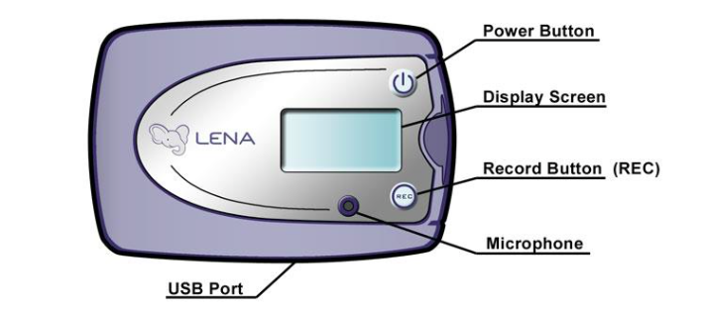

Your infant’s ID # is _______________________________

Today’s date is __________________ Date returned __________________

